**Image Gallery Instructions**

For this assignment you will create a full-screen carousel, displaying images from the UW Football season.

**Slide 1** [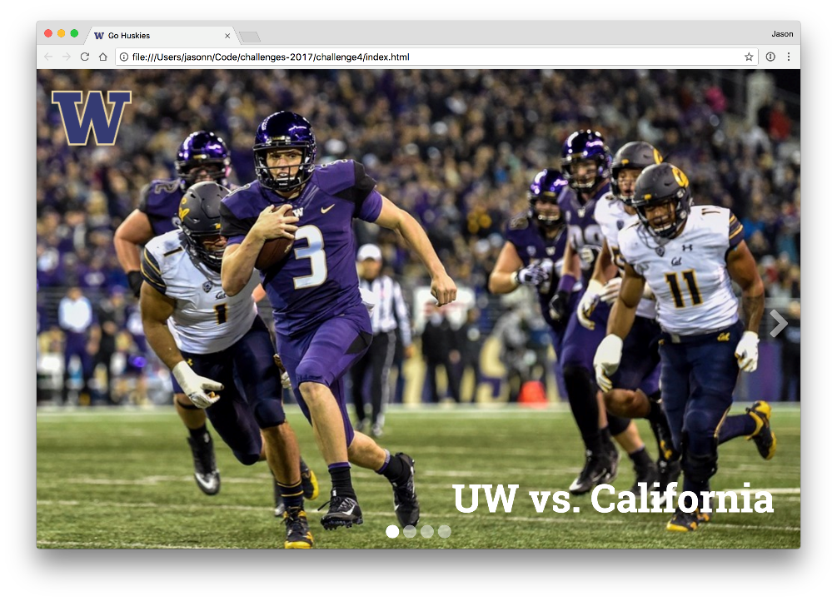](https://camo.githubusercontent.com/88de7e62144b374e8fb0869652f3e326e7c1012e/68747470733a2f2f692e696d6775722e636f6d2f5875734a326e672e706e67)

**Mobile**

[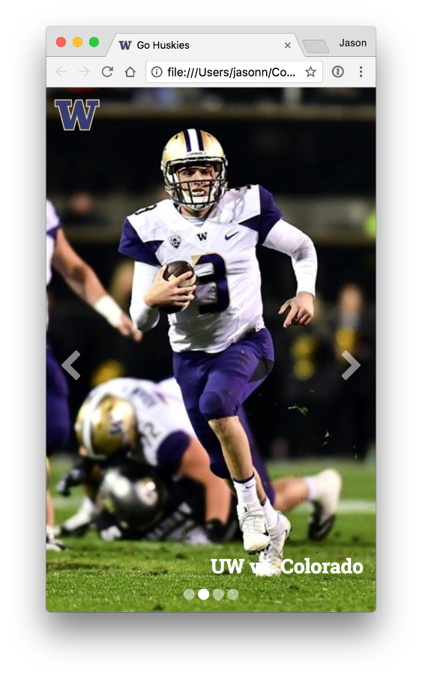](https://camo.githubusercontent.com/a3645030a9d6c635715b221b109ea1bdb993c384/68747470733a2f2f692e696d6775722e636f6d2f716a3668316b762e706e67)

**Requirements**

**A. Slide size**

1. ~~The image gallery must take 100% of the height and width of the browser window, regardless of the size of the browser, and should dynamically resize as you grow/shrink the browser.~~
2. ~~The user~~**~~should not have the ability to scroll any part of the page~~**~~, and the scroll bars must not be visible.~~
3. ~~For this assignment, "desktop" is considering above 768px and "mobile" is considered equal to or below 768px.~~

**B. Slide contents**

1. ~~The images for each slide are provided in the img folder. The slides should be displayed in the following order: California, Colorado, Fresno State, Oregon State.~~
2. ~~Each image should cover the entire space of the browser window, and should be positioned such that they are centered horizonally and are aligned vertically to the top of the screen.~~
3. ~~Each slide should have a large heading labeling each picture, which should slide with image as the carousel changes between images.~~
4. ~~The slide headings should use the Roboto Slab font, with a weight of 900, and be 60px on desktop and 24px on mobile.~~
5. ~~They should be positioned in the bottom right of each slide. On mobile, they should be closer to the sides, as you have less space. (set different IDs like slides?)~~
6. The headings should not overlap the arrows or dots.
7. ~~The UW logo should remain fixed in the top left corner of the browser for all slides, and should not move when transitioning between slides. On mobile devices, it should be about 50% of its normal size.~~

**C. Navigation**

**Arrows**

[](https://camo.githubusercontent.com/2326eb6d0fa4f57b7633cc4c15dbb1fe24a725ba/68747470733a2f2f692e696d6775722e636f6d2f7362656d7430502e676966)[](https://camo.githubusercontent.com/691e37070df5244692d6019f8d7305b49c32e9c0/68747470733a2f2f692e696d6775722e636f6d2f6d6e68736c436c2e676966)

**Dots**

1. ~~To switch between slides, user should be able to click the left and right arrow buttons. These are positioned on their respective sides of the screen, 50% from the top of the page~~.
2. ~~When the user is viewing the first slide, the left arrow should not be visible. When the user is viewing the last slide, the right arrow should not be visible. NOT NEEDED CIRCULAR~~
3. ~~When the arrows are not being used, they should be semi-transparent. When a user hovers and/or clicks on them, they should have full opacity, and the user's~~[~~cursor~~](https://developer.mozilla.org/en-US/docs/Web/CSS/cursor)~~should change to the same cursor used for links.~~
4. ~~There should be four dots at the bottom of the paage, one for each slide. When a user is viewing a particular slide, the dot for that slide should have its full opacity (including when the page first loads). Otherwise, they should be semi-transparent.~~
5. ~~The dots must always be centered at the bottom of the screen, and be slightly smaller on mobile browsers.~~
6. ~~The transition between slides should should animate the horizontal position (the animation shown above lasted 1 second).~~

**D. Extra Credit**

1. **Clickable dots** (5 points): Make the dots at the bottom of the page clickable, e.g. clicking the second dot transitions to the second slide, regardless of which slide you are currently on. The dots should have the same hover effect as the arrows.
2. **~~Circular carousel~~**~~(5 points): Enable the user to go directly from the last slide in the gallery to first slide by clicking the right arrow, and from the first slide in the gallery to the last slide by clicking the left arrow. For full credit, the slides must animate in the expected direction for each arrow, i.e. clicking the right arrow on the last slide must transition to the first slide from right to left, and vice versa.~~
3. **~~Keyboard navigation~~**~~(5 points): Enable the user to navigate the slide show with their keyboard by using the left and right arrow keys~~.

**Third-party libraries**

While you may use the CSS from Bootstrap, you may not use Bootstrap's JavaScript, or any other third-party JavaScript library such as jQuery or any carousel libaries.

**Validate your code**

Use the [HTML Validation Service](https://validator.w3.org/#validate_by_upload) to validate your HTML and fix any errors or warnings that are reported. The report should contain specific instructions and/or links that will help you fix the problems.

Also use the [CSS Validation Service](http://jigsaw.w3.org/css-validator/#validate_by_upload) to validate your CSS and fix any errors or warnings that are reported.

**We will run your HTML and CSS through these validators and you will lose points if any errors/warning are reported!**

**Commit your files**

Whenever you complete some work that you want to commit, add all your changed files to your local git repo, commit the changes, and push your challenge4 branch to GitHub. Include a sensible commit message so that other developers (including us) can understand what changed in this commit.

**Publish to GitHub Pages**

To publish your page to the web, create a new branch in your repo named gh-pages, and merge all commits you've made to the challenge4 branch into the gh-pages branch. Then push this new gh-pages branch to GitHub. After the push is complete, you should be able to see your page at the following URL, replacing your-github-username with your GitHub user name.

https://info343a-au17.github.io/challenges-your-github-username/challenge4/

You can do this directly on your personal computer before pushing to Github, i.e. you do not need to use a pull request to merge your code in the gh-pages branch.

**Open pull request**

On GitHub, create a new pull request to merge your commits from the challenge4 branch to the master branch, but do not complete the merge yourself. Your grader will complete the merge after grading and adding in-line comments to your pull-request code.

In the pull request description, please briefly describe your page and provide a link to your page publish on Github Pages.